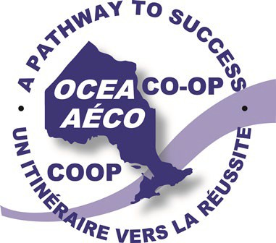ONTARIO COOPERATIVE EDUCATION ASSOCIATION (OCEA)

**ASSOCIATION DE L’ÉDUCATION COOPÉRATIVE DE L’ONTARIO (AÉCO)**

[**https://ocea.on.ca/**](https://ocea.on.ca/)

Are you an Ontario **EMPLOYER** that is **interested** in having a **high school Cooperative Education student** in your workplace? If so, please complete the information at the bottom of this posting and send to ***Carol Madsen*** at [ocea@rogers.com.](mailto:ocea@rogers.com)

Your company information will be added to the ***“NEW”* Employers** area of our website, which is in the ***RESOURCES*** section: <https://ocea.on.ca/en/resources/employers/>. Cooperative Education and all other forms of Experiential Learning teachers from your area will contact you directly.

The ***Ontario Cooperative Education Association (OCEA)*** is a provincial hub for educators involved in Cooperative Education and all other forms of Experiential Learning, who are seeking placements for their high school students.

**COOPERATIVE EDUCATION** IS THE HIGH SCHOOL COURSE, and these are the specialized **COOPERATIVE EDUCATION** student opportunities / programs:

* Ontario Youth Apprenticeship Program (OYAP)
* Specialist High Skills Major (SHSM) Program
* School-Work Transition Programs

***Employers + high school Cooperative Education teachers = Cooperative Education: It’s Working!***

**PLEASE COMPLETE THE FOLLOWING INFORMATION AND RETURN TO:** [**OCEA@ROGERS.COM**](mailto:ocea@rogers.com)

|  |  |
| --- | --- |
| Company Name: | Date: |
| Main Contact’s Name (first / last): | Work Title: |
| Complete Mailing Address: | Website: |
| Phone number (with area code): | Email: |

**Job category / description for Cooperative Education student that you are seeking for placement:**

|  |
| --- |
|  |